Hi!
If you read this document so you bought my asset!
In this asset everything are simple. Code is easy and has summaries.

- In the version of asset 5.0.0 and earlier we should install Google Admob package downloading the latest version of Admob plugin for Unity from here
https://github.com/googleads/googleads-mobile-unity/releases/tag/v8.5.3 and open asset in Unity 2021 and upper (because of it is a requirement for Admob plugin) then we should complete import GoogleMobileAds.unitypackage to project. And finish steps from guide here: https://developers.google.com/admob/unity/start
- Starting from version 5.1.0 I register dependencies to external packages into manifest:
- " com.google.ads.mobile"
- "com.unity.nuget.newtonsoft-json"
- "com.google.external-dependency-manager"
So if you have already imported Json .Net or Google Mobile Ads package please remove it from your project.
- Also we should upgrade Unity to 2022 LTS to completely build project for mobile.
- Go to Project Settings > Player > Android > Publishing Settings > Build and select:
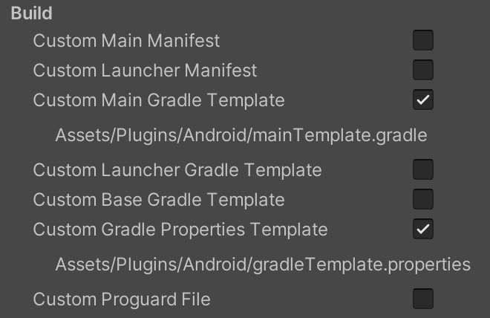

- In the Unity editor click for Android:
Menu→Assets→External Dependency Manager→Android Resolver→Force Resolve.
For iOS:
Menu→Assets→External Dependency Manager→ iOS Resolver → Install Cocoapods
- Then to show advertisement in your build you need to change advertisement id.
Open InterVideoAds.cs script in the scene, (It was added to object AdsManager) and change it there.
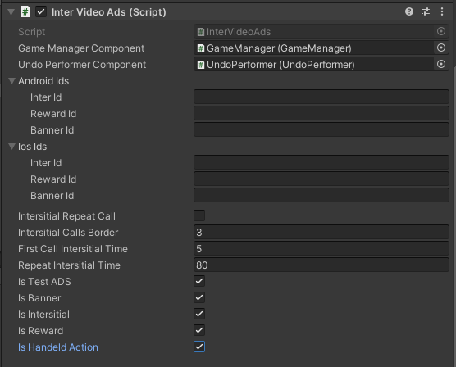
And GoogleMobileAdsSettings.asset
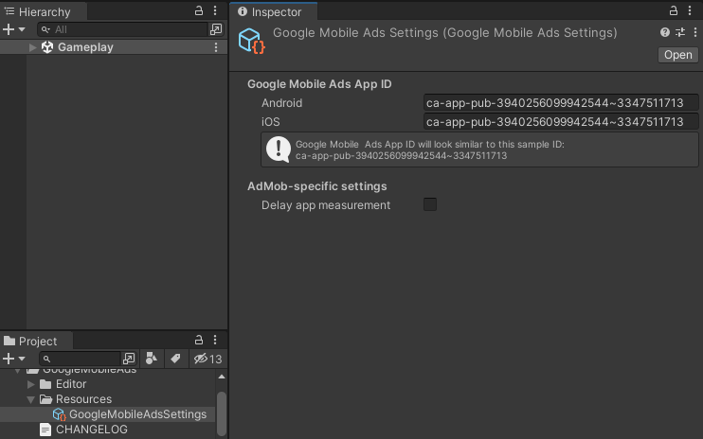

- For activating test ADS you should set IsTestADS variable to TRUE before play (like on screen). For deactivating test ADS you should set IsTestADS variable to FALSE before play.
Undo
Undo logic has option for counting available uses. When counter equals 0 for getting additional uses user should watch Rewarded video. More information in videos at asset page. 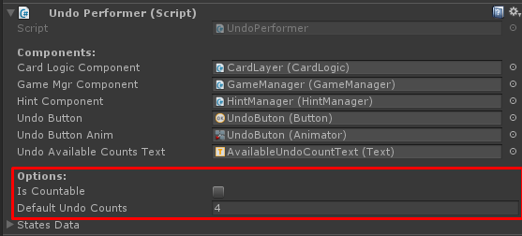
Last game option
You can enable/disable it at GameManager component.
Principle of work: User open new game session. When user close application the system save last game state(decks, cards, score, time, steps). When user open game again the system show popup:

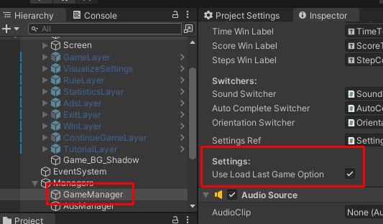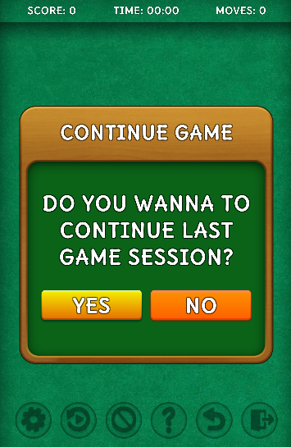
Hand orientation mode
Include two modes: Left-handed and Right-handed
You can enable/disable this feature in VisualizeSettings window.

Auto Complete
Include mode: FullGameSession
FullGameSession mode appear auto complete button every time when user has available move during the game session
You can enable/disable this feature in VisualizeSettings window.
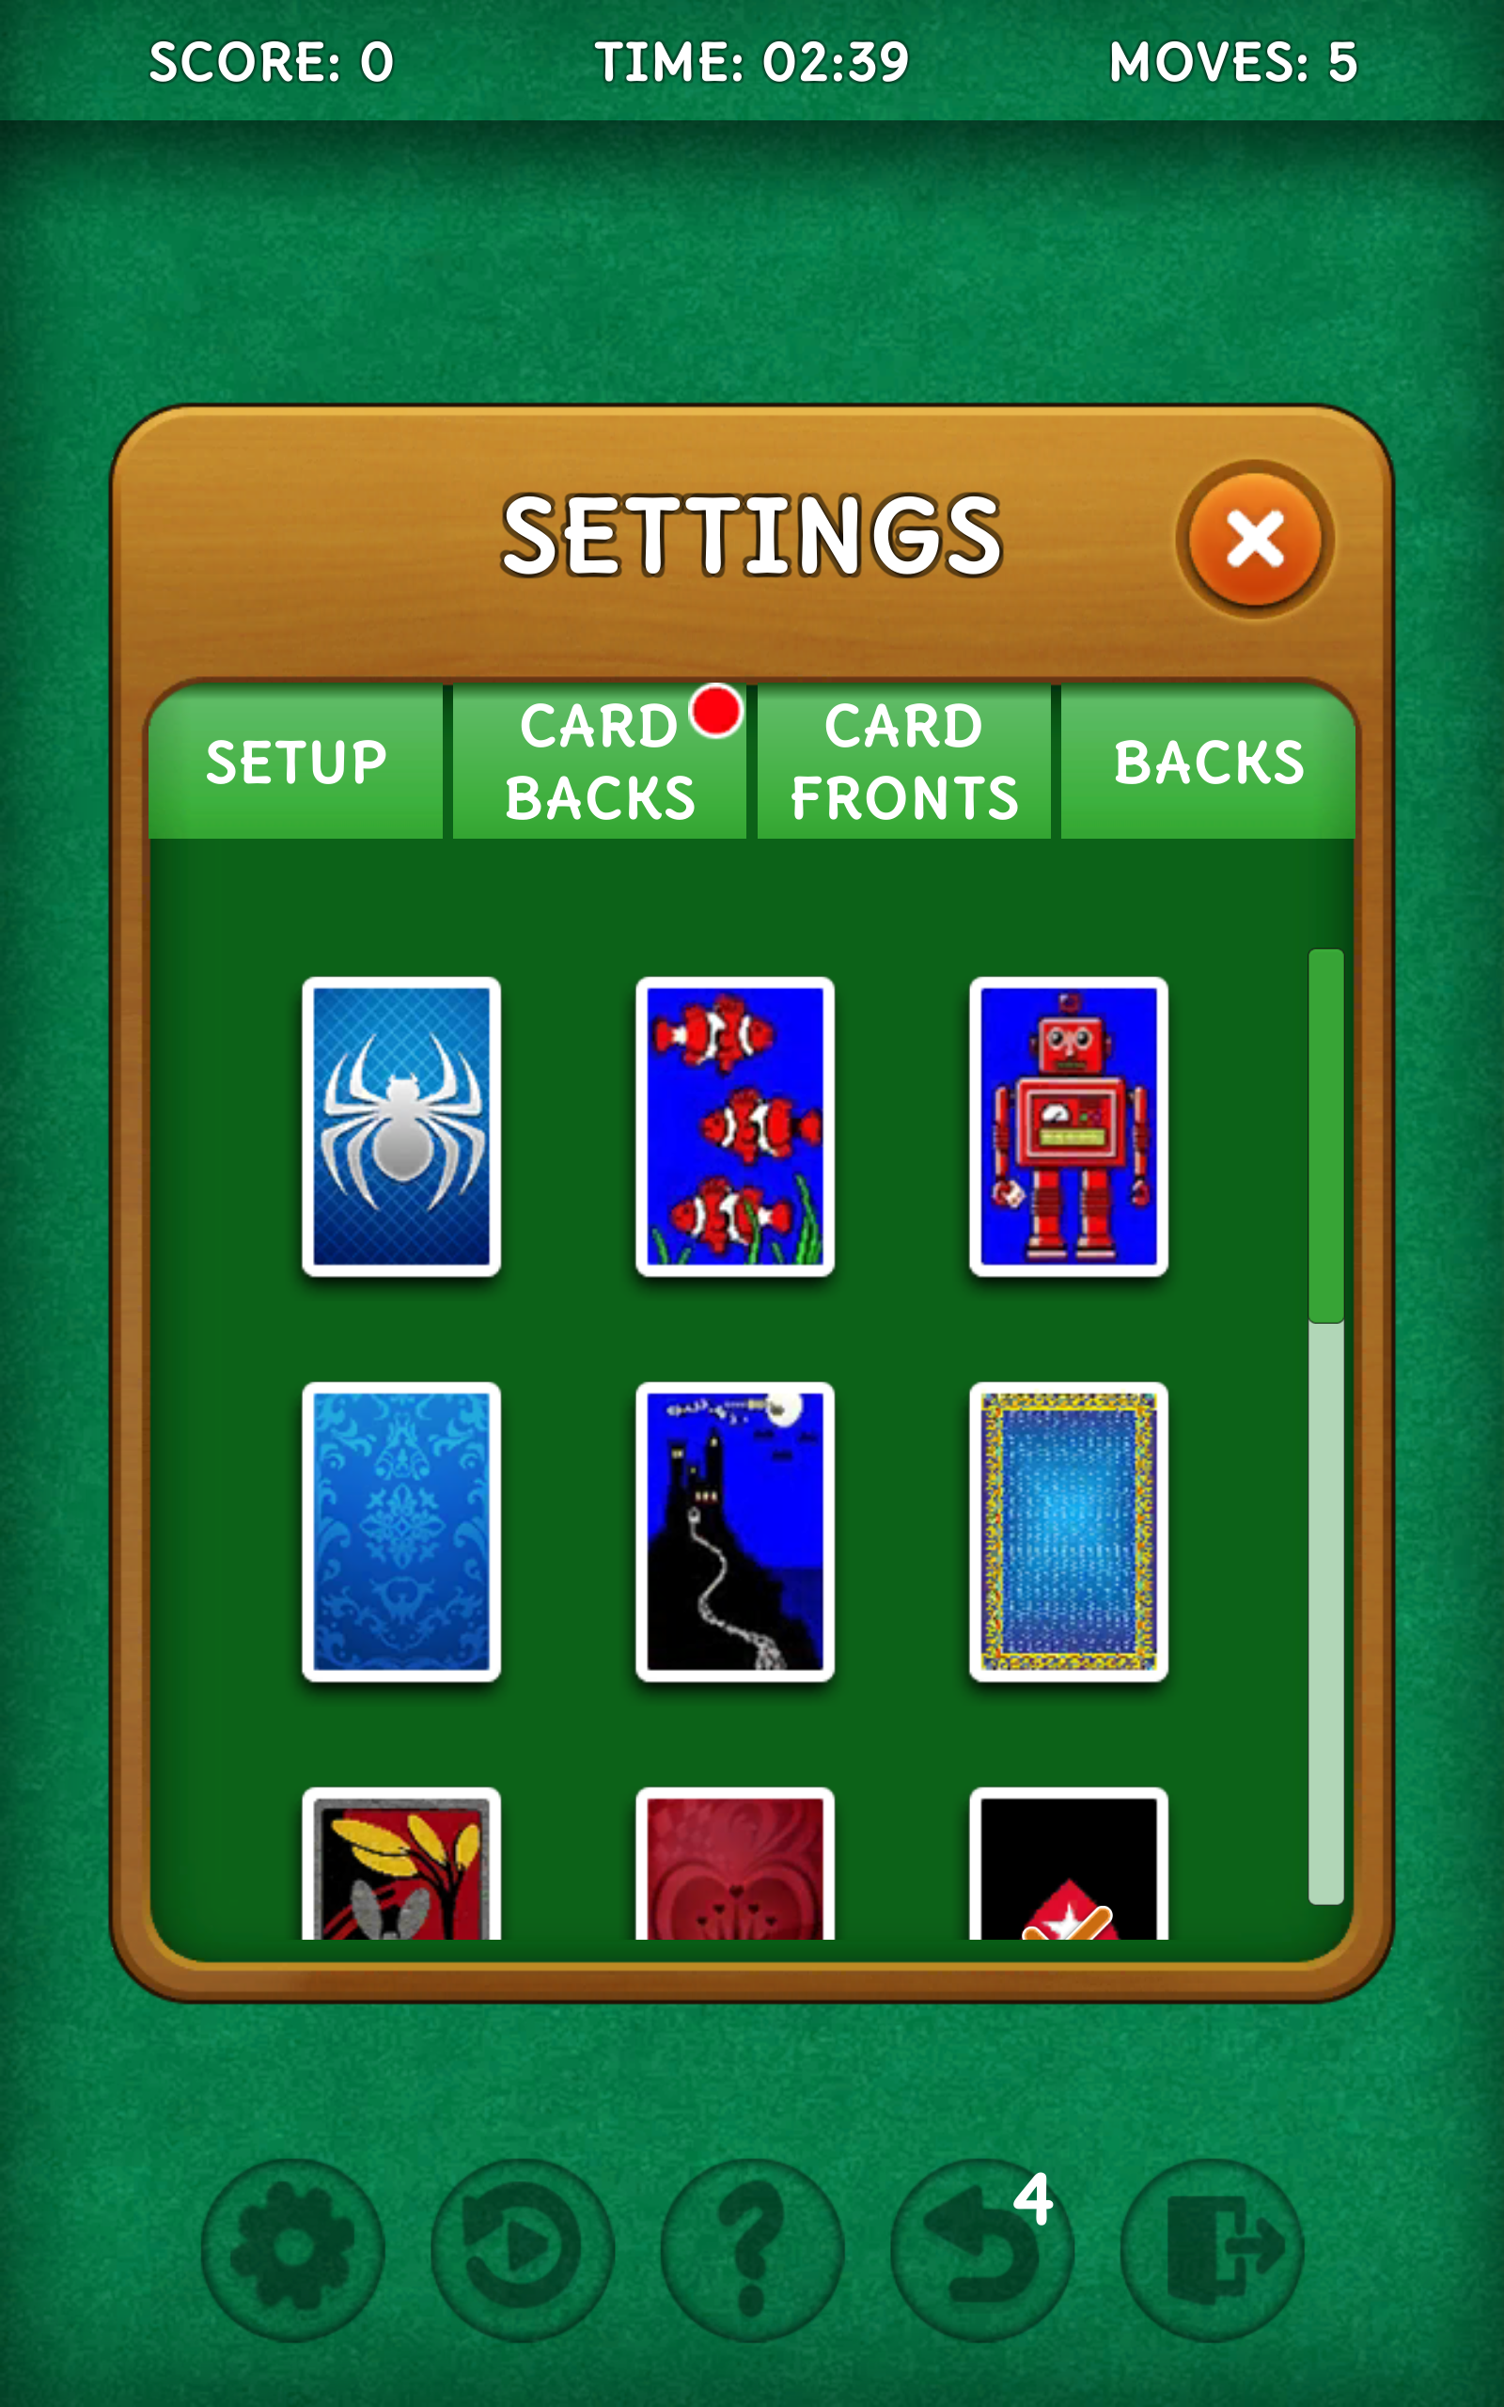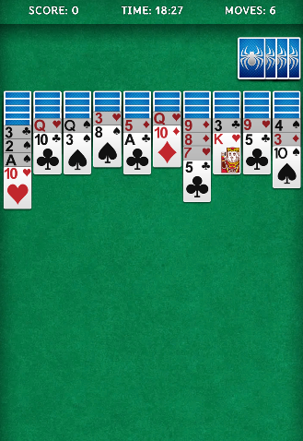

Suits count mode
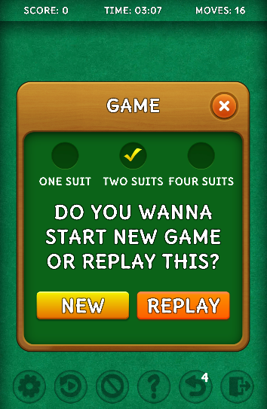
You can open game Window from this layer and setup necessary suits count by activating specific toggle and click New or Replay buttons to appy choose.

For other questions write me an email: support@selvassets.ltd.ua
Thank you in advance!

